Jenkins – Interview

Master Slave

What are the ways to configure Jenkins node agent to communicate with Jenkins master?

Agent: It is directive to tell Jenkins to execute the pipeline in a particular manner and order.
Post-section: If we have to add some notification and to perform other tasks at the end of a pipeline, post-section will definitely run at the end of every pipeline’s execution.
Jenkinsfile: The text file where all the definitions of pipelines are defined is called Jenkinsfile. It is being checked in the source control repository
https://dzone.com/articles/jenkins-03-configure-master-and-slave

types of pipelines in Jenkins?
In Jenkins, a pipeline is a group of events or jobs which are interlinked with one another in a sequence.
Jenkins pipelines can be defined using a text file called JenkinsFile. You can implement pipeline as code using JenkinsFile, and this can be defined by using a domain specific language (DSL). With JenkinsFile, you can write the steps needed for running a Jenkins pipeline

There are two types of syntax used for defining your JenkinsFile.
- Declarative
- Scripted
Declarative:
Declarative pipeline syntax offers an easy way to create pipelines. It contains a predefined hierarchy to create Jenkins pipelines. It gives you the ability to control all aspects of a pipeline execution in a simple, straight-forward manner.
Scripted:
Scripted Jenkins pipeline runs on the Jenkins master with the help of a lightweight executor. It uses very few resources to translate the pipeline into atomic commands. Both declarative and scripted syntax are different from each other and are defined totally differently.

Declarative Pipeline for Maven Projects
Install the plugin from Manage Jenkins
Go to Jenkins Dashboard -> Manage Jenkins -> Manage Plugins -> Available -> search for ‘Build Pipeline’ -> Click on ‘Install without restart’

New Job > PipeLine. 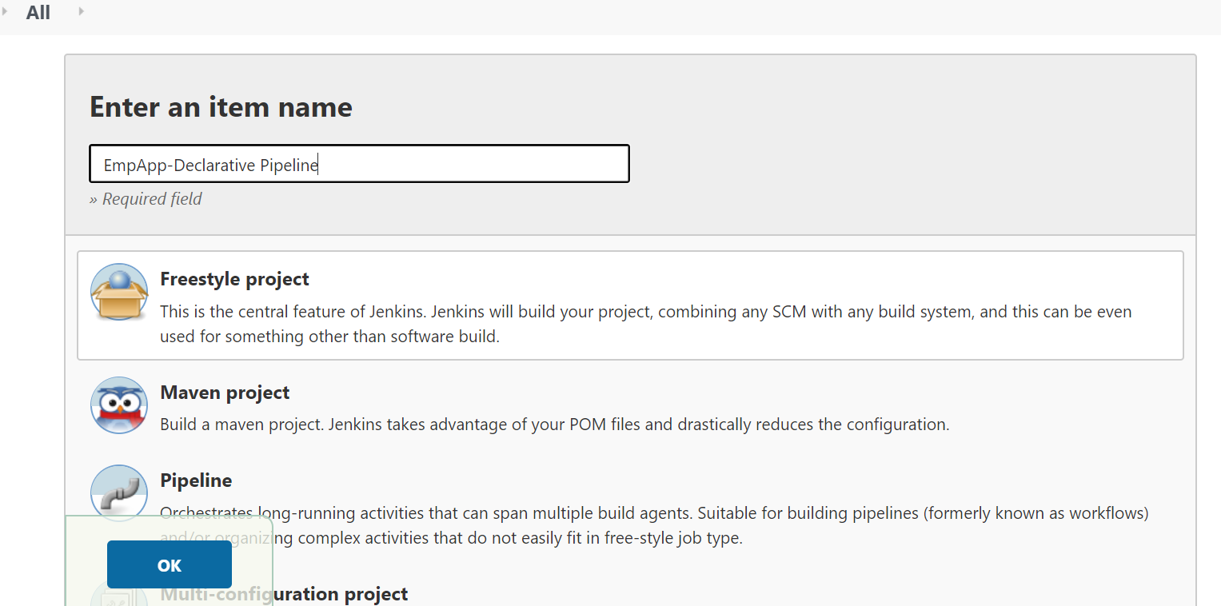

#1 Just Printing message on Build Stage
pipeline {
agent any
stages {
stage('Build') {
steps {
echo 'This is a minimal pipeline.'
}
}
}
}
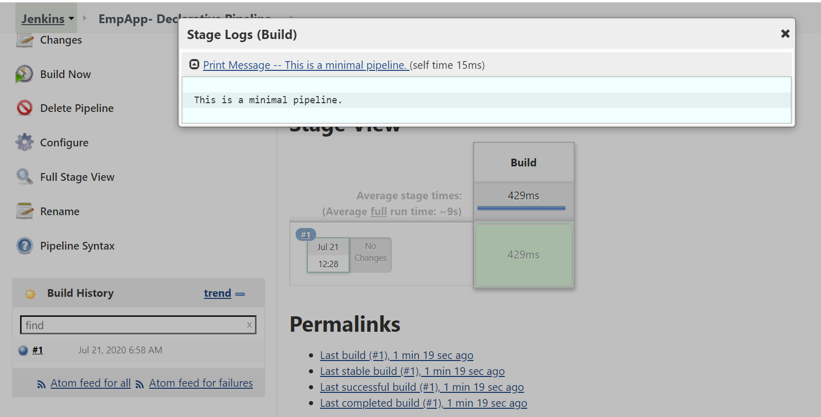

#2 Check JDK, Maven & Print PATHS
pipeline {
agent any
tools {
maven 'Apache Maven 3.6.0'
jdk 'java-8-openjdk'
}
stages {
stage ('Initialize') {
steps {
sh '''
echo "PATH = ${PATH}"
echo "M2_HOME = ${M2_HOME}"
'''
}
}

stage ('Build') {
steps {
echo 'This is a minimal pipeline.'
}
}
}
}
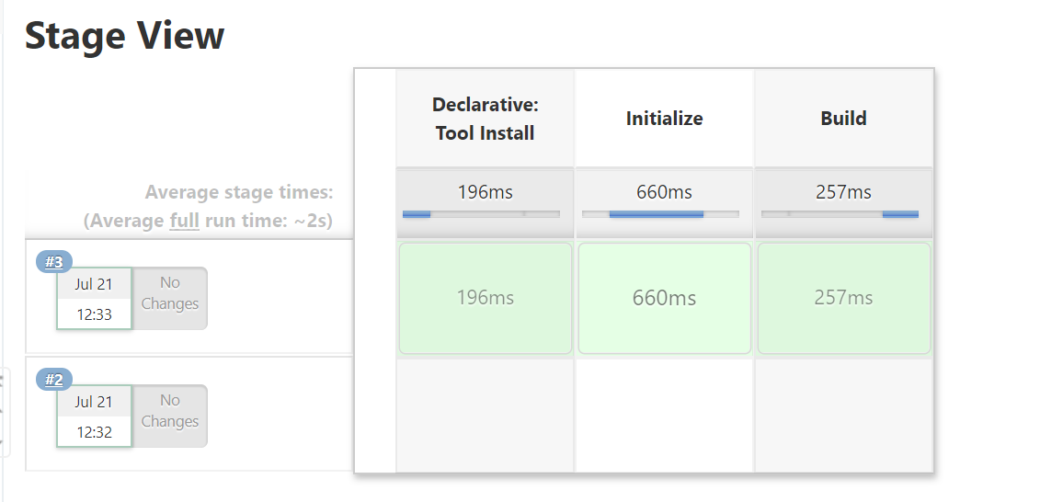
#3 Github integration

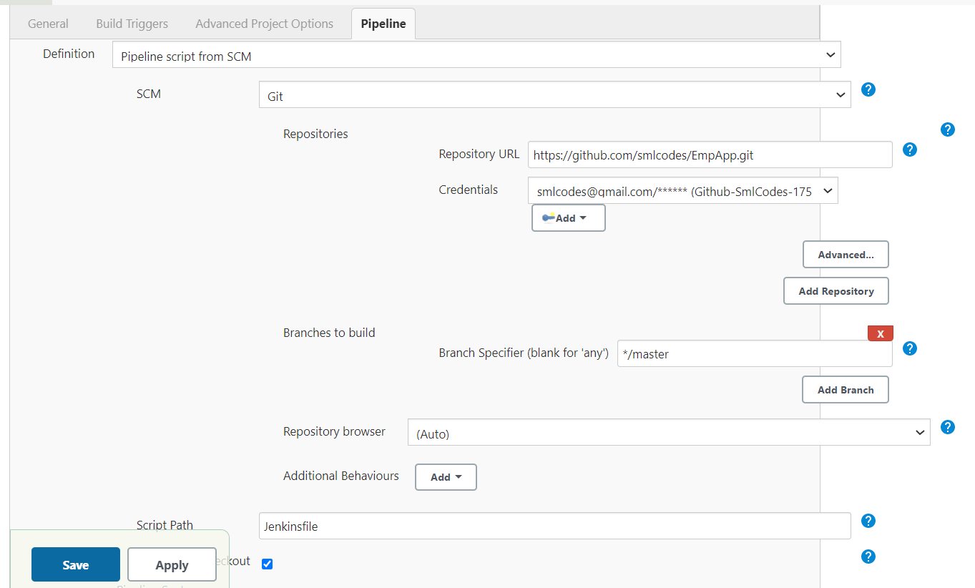
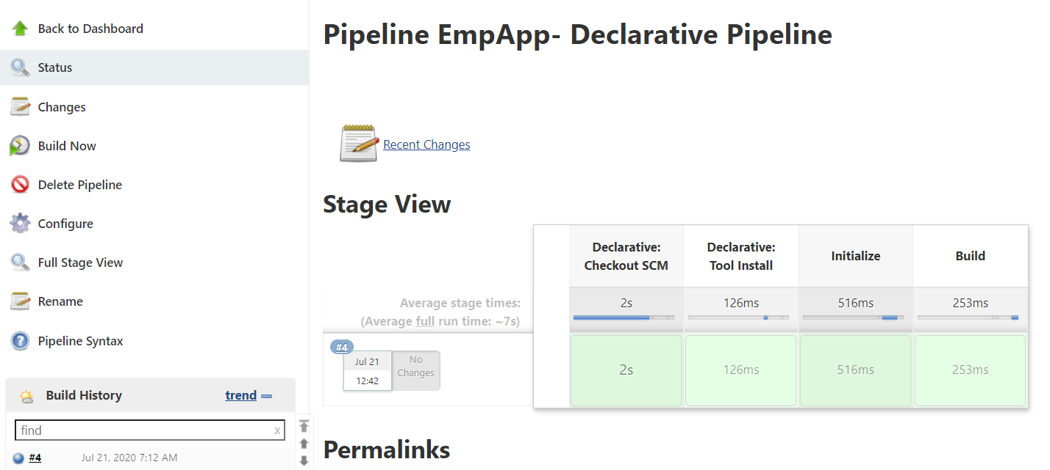

#Maven build

pipeline {
agent any
tools {
maven 'Apache Maven 3.6.0'
jdk 'java-8-openjdk'
}
stages {
stage ('Initialize') {
steps {
sh '''
echo "PATH = ${PATH}"
echo "M2_HOME = ${M2_HOME}"
'''
}
}

stage ('Build') {
steps {
sh 'mvn -Dmaven.test.failure.ignore=true install'
}
post {
success {
junit 'target/surefire-reports/**/*.xml'
}
}
}
}
}
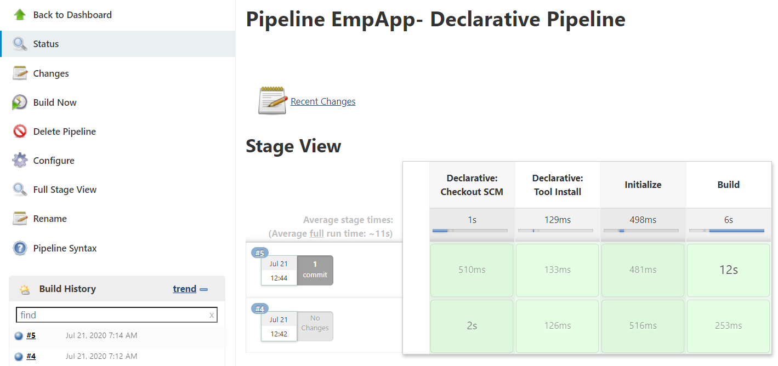

#SoanrQube Integration
pipeline {
agent any
tools {
maven 'Apache Maven 3.6.0'
jdk 'java-8-openjdk'
}
stages {
stage('Initialize') {
steps {
sh '''
echo "PATH = ${PATH}"
echo "M2_HOME = ${M2_HOME}"
'''
}
}

stage('Build') {
steps {
sh 'mvn -Dmaven.test.failure.ignore=true install'
}
post {
success {
junit 'target/surefire-reports/**/*.xml'
}
}
}
stage('SonarQube Analysis') {
steps {
withSonarQubeEnv('SonarQube-Windows-Ec2') {
sh 'mvn org.sonarsource.scanner.maven:sonar-maven-plugin:3.2:sonar'
}
}
}
}
}

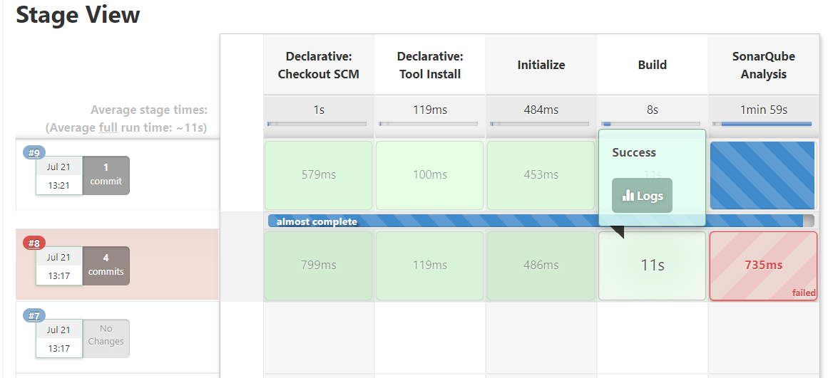

Ref.
https://www.edureka.co/blog/jenkins-pipeline-tutorial-continuous-delivery

https://medium.com/@anusha.sharma3010/ci-cd-using-jenkins-pipeline-as-code-8879e08031e2

https://www.jenkins.io/blog/2017/02/07/declarative-maven-project/(Best2)
https://www.svds.com/create-continuous-delivery-pipeline-maven-project/(Best)

Multibranch Pipeline
https://dzone.com/articles/implement-ci-for-multibranch-pipeline-in-jenkins
The Multibranch Pipeline project type enables you to implement different Jenkinsfile for different branches of the same project. In a Multibranch Pipeline project, Jenkins automatically discovers, manages and executes Pipelines for branches that contain an in-source control.
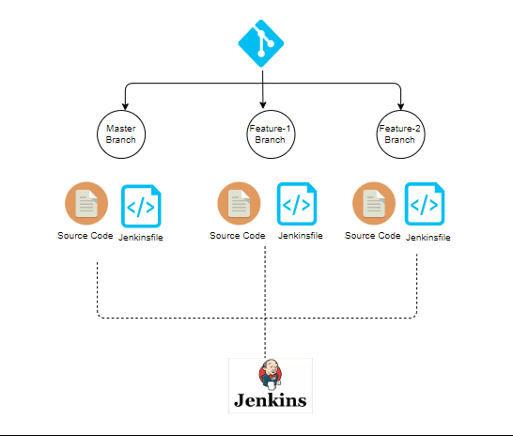
select Multibranch Pipeline
On branch resources, Enter the GitHub Repo, username, Password, ID, and Description 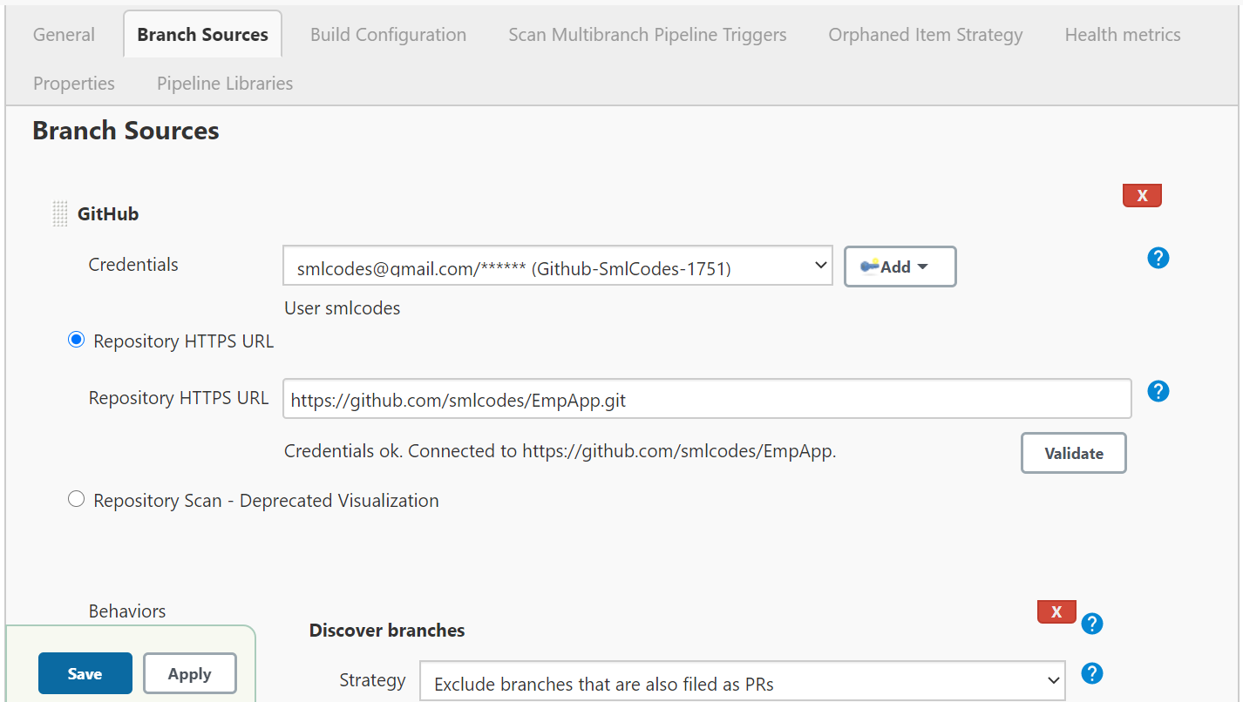
Save the Multibranch Pipeline project.Jenkins automatically scans the designated repository and does some indexing for organization folders.
Once jobs are created build triggers automatically.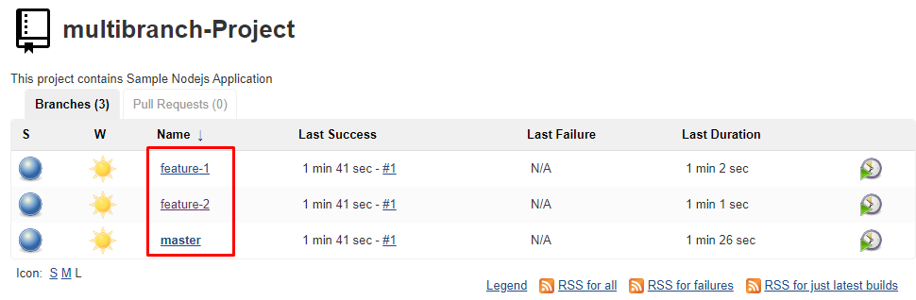

Jenkins Environment Variable Example
Already used in Pipeline Scripts.

What are the system requirements to install Jenkins?
Answer: The minimum configuration required is –
- 256MB of RAM
- 1 GB of drive space
- Java
- Web browser

How do you install Jenkins?
Answer: To install Jenkins, make sure the following are installed –
- Java (version 8)
- Apache Tomcat (version 9)
Download the Jenkins war file and deploy it using Tomcat. You can choose to install the plugins suggested by Jenkins during the installation itself. Once the installation is done, you will be able to see the Jenkins dashboard.

How is continuous integration achieved using Jenkins?
Answer: Here are the steps –
- All the developers commit their source code changes to the shared Git repository.
- Jenkins server checks the shared Git repository at specified intervals and detected changes are then taken into the build.
- The build results and test results are shared to the developers
- The built application is displayed on a test server like Selenium and automated tests are ran.
- The clean and tested build is deployed to the production server.

What is the difference between Jenkins and Bamboo?
Parameters | Jenkins | Bamboo
Open Source | Jenkin is open-source | Bamboo is not open source
Pricing Logic | Jenkin is completely free | It charges for the number of build agents required
Operating System | Windows, Ubuntu, Red Hat, Mac OS | Windows, Linux, Solaris
Browsers | Chrome, Firefox, Internet Explorer | Firefox, Chrome, Safari, Edge
Plugin Support | Yes, It supports a lot of plugins | It does not support many plugins as compared to Jenkins
Support | Being open-source, it has a lot of support from communities | It has less support as compared to Jenkins

What are the benefits of using Jenkins?
I will suggest you include the following benefits of Jenkins if you can recall any other benefit apart from the below-mentioned points you can include that as well.
- At the integration stage, you can cache build failures.
- For each change in the source code, you generate an automatic build report notification.
- To notify developers about build report success or failure, Jenkins integrates with the LDAP mail server.
- Achieves continuous integration agile development and test driven development.
- With simple steps, you can automate the maven release project.
- Easy tracking of bugs at an early stage in a development environment than production.

Explain how you can move or copy Jenkins from one server to another?
- Slide a job from one installation of Jenkins to another by copying the related job directory
- Make a copy of an already existing job by making clone of a job directory by a different name
- Renaming an existing job by renaming a directory.
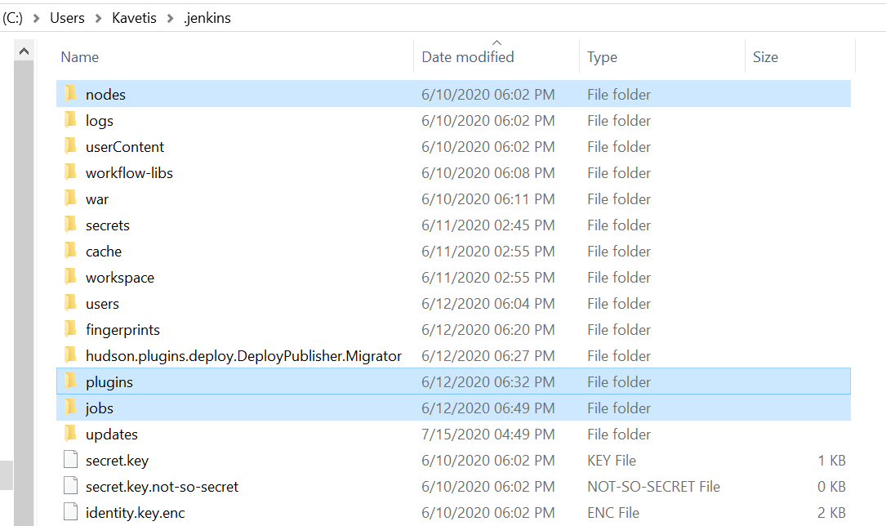

Mention what are the commands you can use to start Jenkins manually?
To start Jenkins manually, you can use either of the following
- (Jenkins_url)/restart: Forces a restart without waiting for builds to complete
- (Jenkin_url)/safeRestart: Allows all running builds to complete

Mention some of the useful plugins in Jenkin?
Some of the important plugins in Jenkin includes
Maven 2 project
Jenkins plugin for building Maven 2/3 jobs
Amazon EC2
HTML publisher
Copy artifact
Join
Green Balls: Changes Hudson to use green balls instead of blue for successful builds. 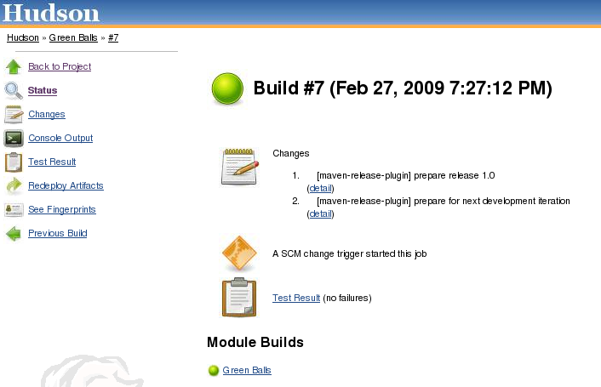
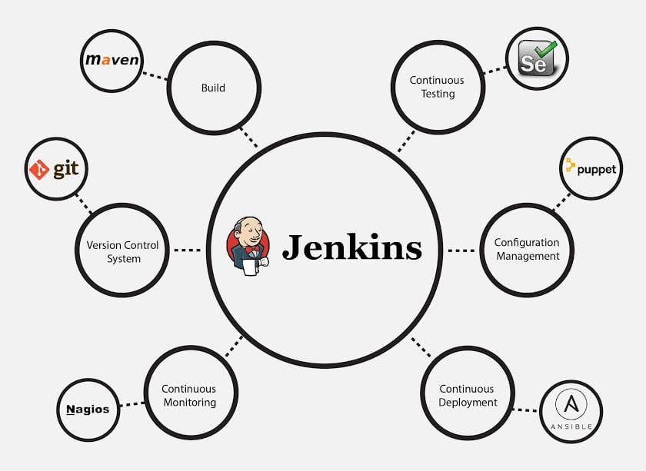

Explain how you can deploy a custom build of a core plugin?
To deploy a custom field of a core plugin, you have to do following things
- Stop Jenkins
- Copy the custom HPI to $Jenkins_Home/plugins
- Delete the previously expanded plugin directory
- Make an empty file called <plugin>.hpi.pinned
- Start Jenkins

Explain how can create a backup and copy files in Jenkins?
Jenkins saves all the setting, build artifacts and logs in its home directory.
to create a back-up of your Jenkins setup, just copy this directory.
You can also copy a job directory to clone or replicate a job or rename the directory. 

Mention what are the two components Jenkins is mainly integrated with?
Jenkin is mainly integrated with two components
- Version Control system like GIT, SVN
- And build tools like Apache Maven

Define the Process of Jenkins.
This is a lengthy answer, and more technical, so take your time memorizing this Jenkins interview question. Here goes:
- Because Jenkins checks changes in repositories regularly, developers must secure their code regularly, too. SCM can be GIT, SVN, and TFS. GIT and SVN are widely used now.
- Once the changes are defined, Jenkins detects them and use them to prep a new build.
- Next, Jenkins will transverse through various stages in its usual pipeline. As one stage successfully finishes, the process moves on to another.
- If a stage fails, the Jenkins build will stop there, and the software will email the team using it. When completed successfully, the code implements itself in the proper server so that testing begins.
- If the testing stage successfully passes, Jenkins shares the results with the team using it. The whole process keeps iterating whenever code is committed to SCM.

Why Is Jenkins Used with Selenium?
Selenium allows you to test Jenkins whenever software changes or sends it to a new environment. Jenkins will then schedule tests to run at times you specify using Selenium.

Name Some of the Top Continuous Integration Tools.
Impress your interviewer by knowing not 1, not 5, but 8 of them. The top Continuous Integration tools are:
- Jenkins
- TeamCity
- Travis CI
- Go CD
- Bamboo
- GitLab CI
- CircleCI
- Codeship

What Is a Build Pipeline?
These Jenkins interview questions are getting harder, no? Don’t worry – we know you can learn them.
For this, the answer is: Build pipeline is the process of automatically starting another job (s) after the execution of a job. Thus, you can start building multi-step build pipelines or rebuild a project when a part of it is updated.

What Is a Jenkins Pipeline?
You can bedazzle your interviewer with your answer here. Pay attention! The answer is, the Jenkins Pipeline plugin is based on a Domain Specific Language (DSL) in Groovy. This Pipeline plugin makes them scriptable and can help you powerfully make complex DevOps pipelines. Groovy, right?

What is Groovy?Why it is used in Jenkins?
Answer: Groovy from Apache is a language for Java platform. It is the native scripting language for Jenkins. Groovy-based plugins enhance Jenkins with great interfaces and build reports that are dynamic and consistent.

What Is a DSL, Jenkins?
If you’re asked this, you impress your interviewer, getting closer to moving on in the interview process. Don’t lose focus now! The DSL Jenkins “Job DSL / Plugin” comprises two items: The Domain Specific Language (DSL) that describes functions using Groovy, and a Jenkins plugin that controls the codes and updates that result within the Jenkins job being done.

Provide Three Ways for Jenkins to Authenticates Users.
Jenkins authenticates users via:
- The default way is to store user data and credentials in an internal database.
- Configure Jenkins to use the authentication mechanism defined by the application server on which it is deployed.
- Configure Jenkins to authenticate against LDAP server.

What Is the Standard Process to Configure Third-party Tools in Jenkins?
Tell your interviewer you use a four-step standard process for third-party tools, such as Artifactory, Node, SonarQube or Git as follows, and you’ll ace this question:
- Install the third-party software.
- Install a Jenkins plug-in supporting the third-party tool through the Jenkins administration console.
- Configure the tool in the “Tools” area of the Manage Jenkins section of the admin console.
- When all this is done, the plug-in is ready to go.
This is one of the trickier Jenkins interview questions, but, thanks to us, you can handle it!

Detail One Jenkins Environment Variable Used in a Shell Script or Batch File.
This one is advanced and shows your knowledge, so let it rip. Convince your interviewer, and you know your stuff here. The answer like this:
Many default Jenkins environmental variables are out there. Some are:
- $JOB_NAME
- $NODE_NAME
- $WORKSPACE
- $BUILD_URL
- $JOB_URL
Then add, when you make new Jenkins plugins, new environmental variables arise

Give a simple use case/scenario to explain how Jenkins works.
Answer:
- Let us say a developer is working on some code changes and eventually commits them to the repository.
- Jenkins server, which constantly checks for changes in the repository, detects the change and pulls the changes to trigger a build.
- The build can fail, in which case the developer is informed with reports.
- If the build passes, it is deployed on to the test server.
- Once the testing is complete, a test report is generated and sent to the developers. This process continues till all the tests are successful, after which code is deployed to production.
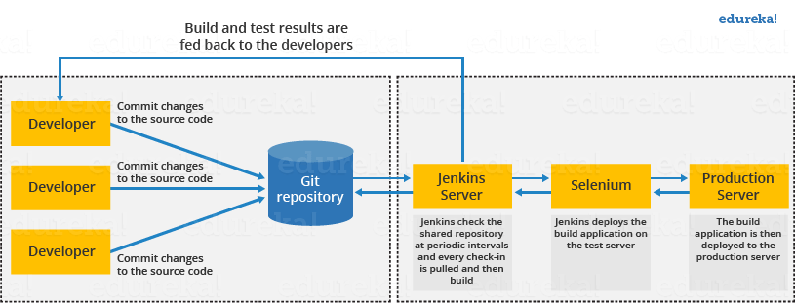

Can you start Jenkins using command line? How?
Answer: Yes, using jenkins.exe start

Question: What are the SCM tools that Jenkins supports?
Answer: The SCM or Source Code Management tools Jenkins supports are SVN, Clearcase, CVS, Git, AccuRev, Perforce, RTC, Mercurial.

Question: What is a job in Jenkins?
Answer: A job or build job is a task or step in the entire build process. It could be compiling the source code, running unit tests, deploying the application to the web server and so on.

Question: How can you create a job?
Answer: On the dashboard page, you can just select a ‘New Job’. When you create a job, you can choose options such as the SCM, triggers to control, the build script and notifications.

Question: What is meant by Jenkins pipeline?
Answer: A pipeline is a group of interlinked jobs done one after the other in a sequence. To integrate and implement continuous delivery pipelines, Jenkins pipelines provides a combination of plugins. The instructions to be performed are given through code.

Question: What are the types of pipelines in Jenkins?
Answer: There are 3 types –
- CI CD pipeline (Continuous Integration Continuous Delivery – manually )
- Scripted pipeline
- Declarative pipeline

What syntax does Jenkins use to schedule build job or SVN polling?
Answer: The cron syntax.
Cron syntax is represented using five asterisks each separated by a space. The syntax is as follows – [minutes] [hours] [day of the month] [month] [day of the week]. Example, if you want to set up a cron for every Monday at 11.59 pm, it would be
59 11 * * 1

What is an agent?
Answer: Agent specifies the execution point for a particular stage in the pipeline or the entire pipeline itself.

What are the ways to configure Jenkins node agent to communicate with Jenkins master?
Answer: There are 2 ways to start the node agent –
- Browser – if Jenkins node agent is launched from a browser, a JNLP (Java Web Start) file is downloaded. This file launches a new process on the client machine to run jobs.
- Command line – to start the node agent using the command line, the client needs the executable agent.jar file. When this file is run, it launches a process on the client to communicate with the Jenkins master to run build jobs.

What is a trigger? Give an example of how the repository is polled when a new commit is detected.
Answer: Triggers define when and how pipelines should be executed.
When Jenkins is integrated with an SCM, for example, Git, the repository can be polled every time there is a commit.
- The Git plugin should be first installed and set up.
- After that, you can build a trigger that specifies when a new build should be started. For example, you can create a job that polls the repository and triggers a build when a change is committed.

Let us say, you have a pipeline. The first job was successful, but the second failed. What should you do next?
Answer: You can restart the pipeline from the point where it failed by doing ‘restart from stage’.

How do you move or copy Jenkins from an old server to a new one?
Answer: All the configurations, settings are stored in the JENKINS_HOME (/var/lib/Jenkins) directory. You should copy the entire home directory to the new server. To do so, you can use the command ‘rsync’.

What is Kubernetes? How can you integrate Jenkins with Kubernetes?
Answer: Kubernetes is a container orchestration tool. With Kubernetes, one can create multiple container instances to achieve more fault tolerance. You can use the Kubernetes deploy plugin to use it with Jenkins for continuous deploy.

Mention what are the commands you can use to start Jenkins manually.
For this answer I will suggest you go with the below-mentioned flow:
To start Jenkins manually open Console/Command line, then go to your Jenkins installation directory. Over there you can use the below commands:
Start Jenkins: jenkins.exe start
Stop Jenkins: jenkins.exe stop
Restart Jenkins: jenkins.exe restart

How will you define Post in Jenkins?
Post is a section that contains several additional steps that might execute after the completion of the pipeline. The execution of all the steps within the condition block depends upon the completion status of the pipeline. The condition block includes the following conditions – changed success, always, failure, unstable and aborted.

What are the various ways in which build can be scheduled in Jenkins?
You can schedule a build in Jenkins in the following ways:
- By source code management commits
- After completion of other builds
- Can be scheduled to run at a specified time (crons)
- Manual Build Requests

Explain the terms Agent, post-section, Jenkinsfile
Agent: It is directive to tell Jenkins to execute the pipeline in a particular manner and order.
Post-section: If we have to add some notification and to perform other tasks at the end of a pipeline, post-section will definitely run at the end of every pipeline’s execution.
Jenkinsfile: The text file where all the definitions of pipelines are defined is called Jenkinsfile. It is being checked in the source control repository.

What are the types of jobs or projects in Jenkins?
These are the types of jobs/projects in Jenkins –
- Freestyle project
- Maven project
- Pipeline
- Multibranch pipeline
- External Job
- Multi-configuration project
- Github organization

Explain how you can move or copy Jenkins from one server to another?
I will approach this task by copying the jobs directory from the old server to the new one. There are multiple ways to do that, I have mentioned it below:
You can:
- Move a job from one installation of Jenkins to another by simply copying the corresponding job directory.
- Make a copy of an existing job by making a clone of a job directory by a different name.
- Rename an existing job by renaming a directory. Note that if you change a job name you will need to change any other job that tries to call the renamed job.

How can you temporarily turn off Jenkins security if the administrative users have locked themselves out of the admin console?
The JENKINS_HOME folder contains a file named config.xml. When you enable the security, this file contains an XML element named useSecurity that changes to true. If you change this setting to false, security will be disabled the next time Jenkins is restarted.
<useSecurity>false</useSecurity>
However, we must understand that disabling security should always be both a last resort and a temporary measure. Once you resolve the authentication issues, make sure that you re-enable Jenkins security and reboot the CI server.

Can you define a Continuous Delivery Workflow?
The flowchart below shows the Continuous Delivery Workflow. Hope it will be much easier to understand with visuals.
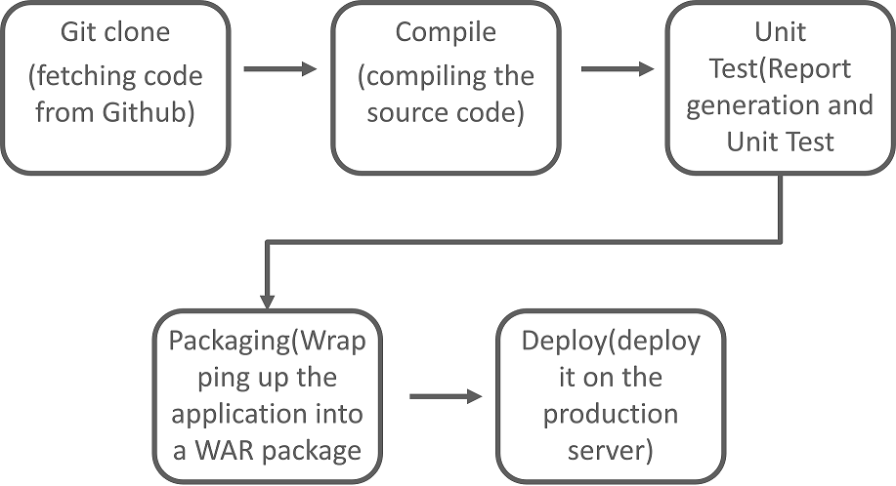

What is the difference between Continuous Delivery and Continuous Deployment?
Continuous Delivery: (Manual Deployment to Production. Does not involve every change to be deployed.)
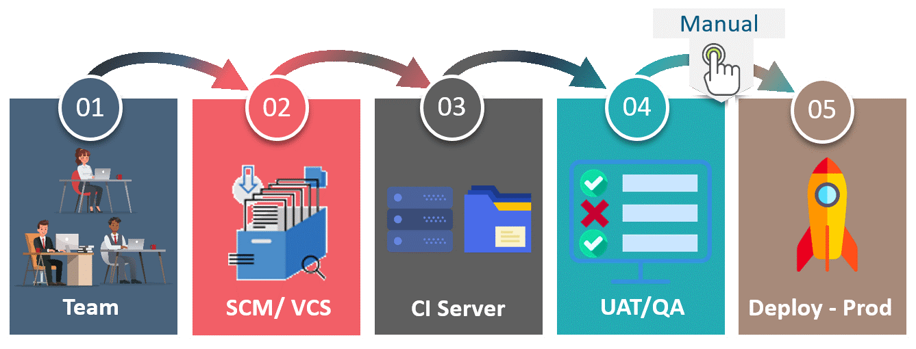Continuous Delivery is a software development practice where you build software in such a way that the software can be released to the production at any time. You achieve Continuous Delivery by continuously integrating the products built by the development team, running automated tests on those built products to detect problems and then push those files into production-like environments to ensure that the software works in production.
Continuous Deployment: (Automated Deployment to Production. Involves deploying every change automatically)
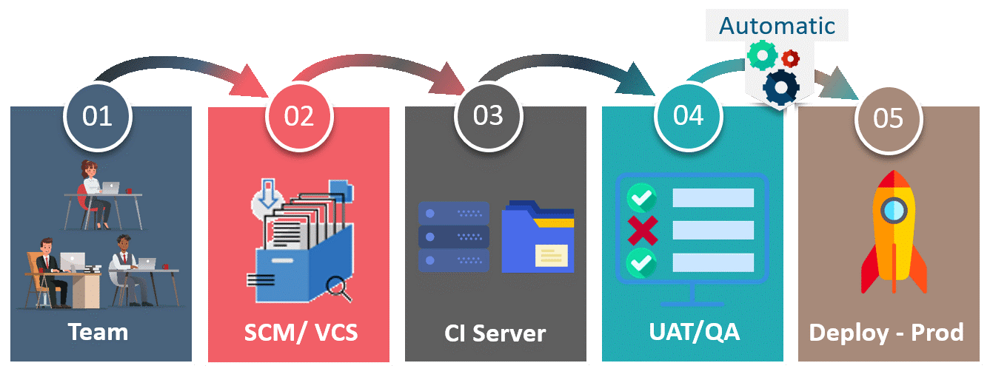Continuous deployment means that every change that you make, goes through the pipeline, and if it passes all the tests, it automatically gets deployed into production. So, with this approach, the quality of the software release completely depends on the quality of the test suite as you have automated everything.

How do you create Multibranch Pipeline in Jenkins?
The Multibranch Pipeline project type enables you to implement different Jenkinsfiles for different branches of the same project. In a Multibranch Pipeline project, Jenkins automatically discovers, manages and executes Pipelines for branches that contain a Jenkinsfile in source control.

What do you mean by Pipeline as a Code?
Pipeline as Code describes a set of features that allow Jenkins users to define pipelined job processes with code, stored and versioned in a source repository. These features allow Jenkins to discover, manage, and run jobs for multiple source repositories and branches — eliminating the need for manual job creation and management.
To use Pipeline as Code, projects must contain a file named Jenkinsfile in the repository root, which contains a “Pipeline script.”
Additionally, one of the enabling jobs needs to be configured in Jenkins:
- Multibranch Pipeline: build multiple branches of a single repository automatically
- Organization Folders: scan a GitHub Organization or Bitbucket Team to discover an organization’s repositories, automatically creating managed Multibranch Pipeline jobs for them

I want to change JDK for all my 1000 jobs. how do you do that? (any other config s)
.jenkins/jobs/job[1..1000]/config.xml
- find all config.xml files
- store in an array
- iterate the array using for loop
- inside the for loop, use sed/awk command for find&replace
- Go to jenkins and say "RELOAD CONFIGURATIONS FROM DISK" so that je nkins can load config changes.

What is parameterised build job?

How do you configure different jenkins jobs to run with different JDKs.

What is crontab and Poll scm? differences? which one you are using? why?
- for compile check we use poll scm - for daily build we use, periodic build option.

What is "Reload configurations from the Disk"? when do you use this?

Do you know how to integrate Jira with Jenkins?

How do you migrate Jenkins from one server to another?
- install jenkins in new machine
- copy .jenkins to new server
- reload configurations from the disk
- restart jenkins
(Note: usually we don't copy workspace as it is source code and contains large s ize of data)

Ref.

AWS – Interview

difference between vertical and horizontal scaling
- Horizontal scaling means that you scale by adding more machines into your pool of resources.
- Vertical scaling means that you scale by adding more power (CPU, RAM) to an existing machine.
An easy way to remember this is to think of a machine on a server rack, we add more machines across the horizontal direction and add more resources to a machine in the vertical direction.
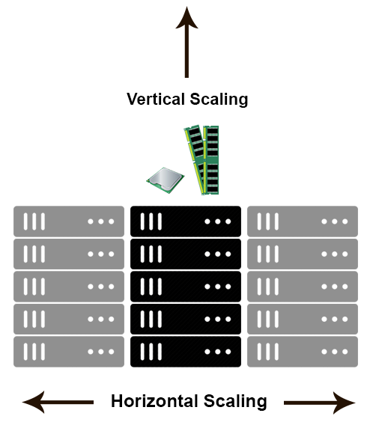
In a database world horizontal-scaling is often based on the partitioning of the data i.e. each node contains only part of the data, in vertical-scaling the data resides on a single node and scaling is done through multi-core i.e. spreading the load between the CPU and RAM resources of that machine.
— horizontal-scaling it is often easier to scale dynamically by adding more machines into the existing pool
— Vertical-scaling is often limited to the capacity of a single machine, scaling beyond that capacity often involves downtime and comes with an upper limit.

Mention what the key components of AWS are?
The key components of AWS are
- Route 53:A DNS web service
- Simple E-mail Service: It allows sending e-mail using RESTFUL API call or via regular SMTP
- Identity and Access Management: It provides enhanced security and identity management for your AWS account
- Simple Storage Device or (S3):It is a storage device and the most widely used AWS service
- Elastic Compute Cloud (EC2): It provides on-demand computing resources for hosting applications. It is handy in case of unpredictable workloads
- Elastic Block Store (EBS):It offers persistent storage volumes that attach to EC2 to allow you to persist data past the lifespan of a single Amazon EC2 instance
- CloudWatch: To monitor AWS resources, It allows administrators to view and collect key Also, one can set a notification alarm in case of trouble.

Explain what S3 is?
S3 stands for Simple Storage Service. You can use S3 interface to store and retrieve any amount of data, at any time and from anywhere on the web. For S3, the payment model is “pay as you go.”

What would be the minimum and maximum size of the individual objects that you can store in S3?
Ans: The minimum size of the object that you can store in S3 is 0 bytes, and the maximum size of an individual object that you can save is 5TB.

Explain the various storage classes available in S3?
Ans: Below mentioned are the storage classes available in S3.
- Standard frequency accessed
- One-zone infrequency accessed
- RRS - reduced redundancy storage
- Standard infrequency accessed
- Glacier

Mention what the difference between Amazon S3 and EC2 is?
The difference between EC2 and Amazon S3 is that
EC2 | S3
- It is a cloud web service used for hosting your application | - It is a data storage system where any amount of data can be stored
- It is like a huge computer machine which can run either Linux or Windows and can handle application like PHP, Python, Apache or any databases | - It has a REST interface and uses secure HMAC-SHA1 authentication keys

What is the role of AWS CloudTrail?
CloudTrail is a specially designed tool for logging and tracking API calls. It helps to audit all S3 bucket accesses.

What is the relation between the Availability Zone and Region?
AWS regions are separate geographical areas, like the US-West 1 (North California) and Asia South (Mumbai). On the other hand, availability zones are the areas that are present inside the regions. These are generally isolated zones that can replicate themselves whenever required.
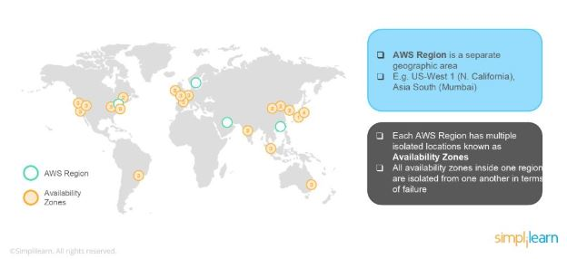

Which AWS region is the cheapest?
Ans: The US standard is the cheapest region; it is also the most established AWS region.

What is auto-scaling?
Auto-scaling is a function that allows you to provision and launch new instances whenever there is a demand. It allows you to automatically increase or decrease resource capacity in relation to the demand.

What is geo-targeting in CloudFront?
CloudFront is a content delivery network offered by AWS, and it speeds up the distribution of dynamic and static web content such as .css, .js, .html and image files to the users. It delivers the content with low latency and high transfer speed to the users. AWS provides CDN for less price and it suits best for startups
How AWS CloudFront Delivers the Content?
AWS CloudFront delivers the content in the following steps.
Step 1 − The user accesses a website and requests an object to download like an image file.
Step 2 − DNS routes your request to the nearest CloudFront edge location to serve the user request.
Step 3 − At edge location, CloudFront checks its cache for the requested files. If found, then returns it to the user otherwise does the following −
- First CloudFront compares the request with the specifications and forwards it to the applicable origin server for the corresponding file type.
- The origin servers send the files back to the CloudFront edge location.
- As soon as the first byte arrives from the origin, CloudFront starts forwarding it to the user and adds the files to the cache in the edge location for the next time when someone again requests for the same file.
Step 4 − The object is now in an edge cache for 24 hours or for the provided duration in file headers. CloudFront does the following −
- CloudFront forwards the next request for the object to the user’s origin to check the edge location version is updated or not.
- If the edge location version is updated, then CloudFront delivers it to the user.
- If the edge location version is not updated, then origin sends the latest version to CloudFront. CloudFront delivers the object to the user and stores the latest version in the cache at that edge location.
How to Set Up AWS CloudFront?
AWS CloudFront can be set up using the following steps.
Step 1 − Sign in to AWS management console using the following link − https://console.aws.amazon.com/
Step 2 − Upload Amazon S3 and choose every permission public. (How to upload content to S3 bucket is discussed in chapter 14)
Step 3 − Create a CloudFront Web Distribution using the following steps.
- Open CloudFront console using the following link − https://console.aws.amazon.com/cloudfront/
- Click the Get Started button in the web section of Select a delivery method for your content page.
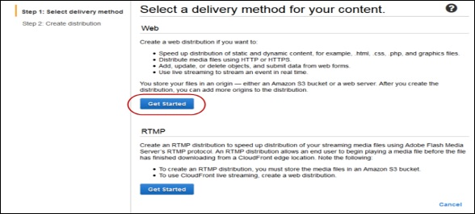
- Create Distribution page opens. Choose the Amazon S3 bucket created in the Origin Domain Name and leave the remaining fields as default.
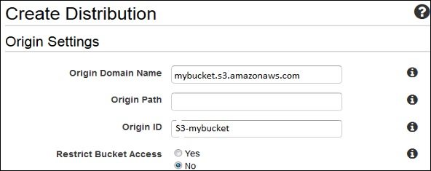
- Default Cache Behavior Settings page opens. Keep the values as default and move to the next page.
- A Distribution settings page opens. Fill the details as per your requirement and click the Create Distribution button.
- The Status column changes from In Progress to Deployed. Enable your distribution by selecting the Enable option. It will take around 15 minutes for the domain name to be available in the Distributions list.
Test the Links
After creating distribution, CloudFront knows the location of Amazon S3 server and the user knows the domain name associated with the distribution. However, we can also create a link to Amazon S3 bucket content with that domain name and have CloudFront serve it. This helps save a lot of time.
Following are the steps to link an object −
Step 1 − Copy the following HTML code to a new file and write the domain-name that CloudFront assigned to the distribution in the place of domain name. Write a file name of Amazon S3 bucket in the place of object-name.
<html>
<head>CloudFront Testing link</head>
<body>
<p>My Cludfront.</p>
<p><img src = "http://domain-name/object-name" alt = "test image"/>
</body>
</html>
Step 2 − Save the text in a file with .html extension.
Step 3 − Open the web page in a browser to test the links to see if they are working correctly. If not, then crosscheck the settings

What is CloudFormation & the steps involved in a CloudFormation Solution?
AWS CloudFormation provides users with a simple way to create and manage a collection of Amazon Web Services (AWS) resources by provisioning and updating them in a predictable way. AWS CloudFormation enables you to manage your complete infrastructure or AWS resources in a text file.
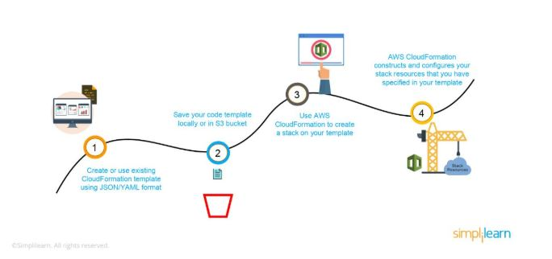
- Create or use an existing CloudFormation template using JSON or YAML format.
- Save the code in an S3 bucket, which serves as a repository for the code.
- Use AWS CloudFormation to call the bucket and create a stack on your template.
- CloudFormation reads the file and understands the services that are called, their order, the relationship between the services, and provisions the services one after the other.
"Ec2Instance" : {
"Type" : "AWS::EC2::Instance",
"Properties" : {
"ImageId" : { "Fn::FindInMap" : [ "AWSRegionArch2AMI", { "Ref" : "AWS::Region" },
{ "Fn::FindInMap" : [ "AWSInstanceType2Arch", { "Ref" : "InstanceType" }, "Arch" ] } ] },
"KeyName" : { "Ref" : "KeyName" },
"InstanceType" : { "Ref" : "InstanceType" },
"SecurityGroups" : [{ "Ref" : "Ec2SecurityGroup" }],
"BlockDeviceMappings" : [
{
"DeviceName" : "/dev/sda1",
"Ebs" : { "VolumeSize" : "50" }
},{
"DeviceName" : "/dev/sdm",
"Ebs" : { "VolumeSize" : "100" }
}
]
}
}
LAMP Stack Example Template
https://s3.ap-south-1.amazonaws.com/cloudformation-templates-ap-south-1/LAMP_Single_Instance.template

What are the native AWS Security logging capabilities?
- Most of the AWS services have their logging options. Also, some of them have an account level logging, like in AWS CloudTrail, AWS Config, and others. Let’s take a look at two services in specific:
AWS CloudTrail
- This is a service that provides a history of the AWS API calls for every account. It lets you perform security analysis, resource change tracking, and compliance auditing of your AWS environment as well. The best part about this service is that it enables you to configure it to send notifications via AWS SNS when new logs are delivered.
AWS Config
- This helps you understand the configuration changes that happen in your environment. This service provides an AWS inventory that includes configuration history, configuration change notification, and relationships between AWS resources. It can also be configured to send information via AWS SNS when new logs are delivered.

What is a DDoS attack, and what services can minimize them?
DDoS is a cyber-attack in which the perpetrator accesses a website and creates multiple sessions so that the other legitimate users cannot access the service. The native tools that can help you deny the DDoS attacks on your AWS services are:
- AWS Shield
- AWS WAF - Web Application Firewall

You are trying to provide a service in a particular region, but you do not see the service in that region. Why is this happening, and how do you fix it?
Not all Amazon AWS services are available in all regions. When Amazon initially launches a new service, it doesn’t get immediately published in all the regions. They start small and then slowly expand to other regions. So, if you don’t see a specific service in your region, chances are the service hasn’t been published in your region yet. However, if you want to get the service that is not available, you can switch to the nearest region that provides the services.

What is SNS?
Ans: Amazon Simple Notification Service (SNS )is a web service provided by the AWS. It manages and delivers the messages or notifications to the users and clients from any cloud platform. In SNS, there are two types of clients: subscribers and publishers. Publishers produce and send a message to the subscriber instance through the communication channels. Subscribers receive the notification from the publisher over one of the supported protocols such as Amazon SQS, HTTP, and Lambda, etc. Amazon SNS automatically triggers the service and sends an email with a message that “ your EC2 instance is growing” when you are using Auto Scaling.

What is SQS?
Ans: Amazon SQS stands for Simple Queue Service, and it manages the message queue service. Using this service, you can move the data or message from one application to another even though it is not in the running or active state. SQS sends messages between multiple services, including S3, DynamoDB, EC2 Instance, and also it uses the Java message queue service to delivery the information. The maximum visibility timeout of a message is 12 hours in the SQS queue.
15) What are the types of queues in SQS?
Ans: There are two types of queues in SQS. They are as follows:
Standard Queues: It is a default queue type. It provides an unlimited number of transactions per second and at least once message delivery option.
FIFO Queues: FIFO queues are designed to ensure that the order of messages is received and sent is strictly preserved as in the exact order that they sent.

How do you set up a system to monitor website metrics in real-time in AWS?
Amazon CloudWatch helps you to monitor the application status of various AWS services and custom events. It helps you to monitor:
- State changes in Amazon EC2
- Auto-scaling lifecycle events
- Scheduled events
- AWS API calls
- Console sign-in events
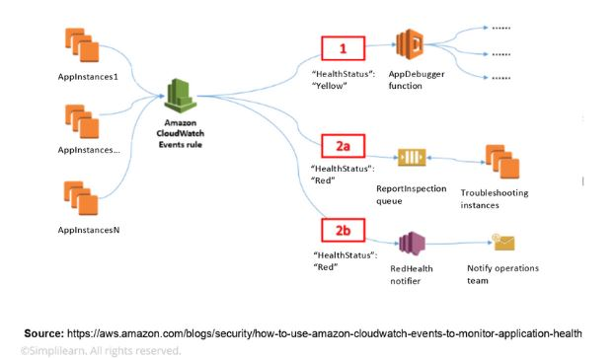

Name some of the AWS services that are not region-specific
AWS services that are not region-specific are:
- IAM
- Route 53
- Web Application Firewall
- CloudFront

What are the differences between NAT Gateways and NAT Instances?
NAT Gateway is a highly available AWS managed service that makes it easy to connect to the Internet from instances within a private subnet in an Amazon Virtual Private Cloud (Amazon VPC). Previously, you needed to launch a NAT instance to enable NAT for instances in a private subnet.
(NAT) instance You can use a network address translation (NAT) instance in a public subnet in your VPC to enable instances in the private subnet to initiate outbound IPv4 traffic to the internet or other AWS services, but prevent the instances from receiving inbound traffic initiated by someone on the internet.
While both NAT Gateways and NAT Instances serve the same function, they still have some key differences.
The following is a high-level summary of the differences between NAT instances and NAT gateways.
Attribute | NAT gateway | NAT instance
Availability | Highly available. NAT gateways in each Availability Zone are implemented with redundancy. Create a NAT gateway in each Availability Zone to ensure zone-independent architecture. | Use a script to manage failover between instances.
Bandwidth | Can scale up to 45 Gbps. | Depends on the bandwidth of the instance type.
Maintenance | Managed by AWS. You do not need to perform any maintenance. | Managed by you, for example, by installing software updates or operating system patches on the instance.
Performance | Software is optimized for handling NAT traffic. | A generic Amazon Linux AMI that's configured to perform NAT.
Cost | Charged depending on the number of NAT gateways you use, duration of usage, and amount of data that you send through the NAT gateways. | Charged depending on the number of NAT instances that you use, duration of usage, and instance type and size.
Type and size | Uniform offering; you don’t need to decide on the type or size. | Choose a suitable instance type and size, according to your predicted workload.
Public IP addresses | Choose the Elastic IP address to associate with a NAT gateway at creation. | Use an Elastic IP address or a public IP address with a NAT instance. You can change the public IP address at any time by associating a new Elastic IP address with the instance.
Private IP addresses | Automatically selected from the subnet's IP address range when you create the gateway. | Assign a specific private IP address from the subnet's IP address range when you launch the instance.
Security groups | Cannot be associated with a NAT gateway. You can associate security groups with your resources behind the NAT gateway to control inbound and outbound traffic. | Associate with your NAT instance and the resources behind your NAT instance to control inbound and outbound traffic.
Network ACLs | Use a network ACL to control the traffic to and from the subnet in which your NAT gateway resides. | Use a network ACL to control the traffic to and from the subnet in which your NAT instance resides.
Flow logs | Use flow logs to capture the traffic. | Use flow logs to capture the traffic.
Port forwarding | Not supported. | Manually customize the configuration to support port forwarding.
Bastion servers | Not supported. | Use as a bastion server.
Traffic metrics | View CloudWatch metrics for the NAT gateway. | View CloudWatch metrics for the instance.
Timeout behavior | When a connection times out, a NAT gateway returns an RST packet to any resources behind the NAT gateway that attempt to continue the connection (it does not send a FIN packet). | When a connection times out, a NAT instance sends a FIN packet to resources behind the NAT instance to close the connection.
IP fragmentation | Supports forwarding of IP fragmented packets for the UDP protocol.  Does not support fragmentation for the TCP and ICMP protocols. Fragmented packets for these protocols will get dropped. | Supports reassembly of IP fragmented packets for the UDP, TCP, and ICMP protocols.

How do you set up SSH agent forwarding so that you do not have to copy the key every time you log in?
Here’s how you accomplish this:
- Go to your PuTTY Configuration
- Go to the category SSH -> Auth
- Enable SSH agent forwarding to your instance
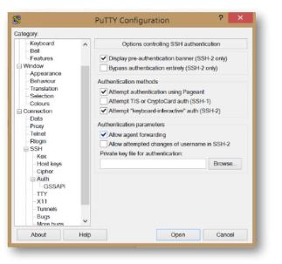

What are Solaris and AIX operating systems? Are they available with AWS?
Solaris is an operating system that uses SPARC processor architecture, which is not supported by the public cloud currently.
AIX is an operating system that runs only on Power CPU and not on Intel, which means that you cannot create AIX instances in EC2.
Since both the operating systems have their limitations, they are not currently available with AWS.

How can you recover/login to an EC2 instance for which you have lost the key?
Follow the steps provided below to recover an EC2 instance if you have lost the key:
- Verify that the EC2Config service is running
- Detach the root volume for the instance
- Attach the volume to a temporary instance
- Modify the configuration file
- Restart the original instance

Explain the types of instances available?
Ans: Below stated are the available instances:
- General-purpose
- Storage optimized
- Accelerated computing
- Computer-optimized
- Memory-optimized

Explain about DynamoDB?
Ans: If you want to have a faster and flexible NoSQL database, then the right thing available is DynamoDB, which is a flexible and efficient database model available in Amazon web services.

What is SimpleDB?
Ans: SimpleDB is one of Amazon services offered by AWS. It is a distributed database and highly available NoSQL data store that offloads the work of database administrators.

What is Glacier?
Ans: Amazon Glacier is one of the most important services provided by AWS. The Glacier is an online web storage service that provides you with low cost and effective storage with security features for archival and data backup. With Glacier, you can store the information effectively for months, years, or even decades.

What is Redshift?
Ans: Redshift is a big data product used as a data warehouse in the cloud. It is the fast, reliable and powerful product of a big data warehouse.

What are the types of load balancers in EC2?
Ans: There are three types of load balancers in EC2. They are as follows:
Application Load Balancer: Application load balancer designed to make routing decisions at the application layer. ALC supports dynamic host port mapping and path-based routings.
Network Load Balancer: Network load balancer is designed to make routing decisions at the transport layer. It handles millions of requests per second. Using the flow hash routing algorithm, NCL selects the target from the target groups after receiving a connection from the load balancer.
Classic Load Balancer: Classic load balancer is designed to make routing decisions either at the application layer or transport layer. It requires a fixed relationship between container instance port and load balancer port.

differences between AWS S3 and EBS & EFS
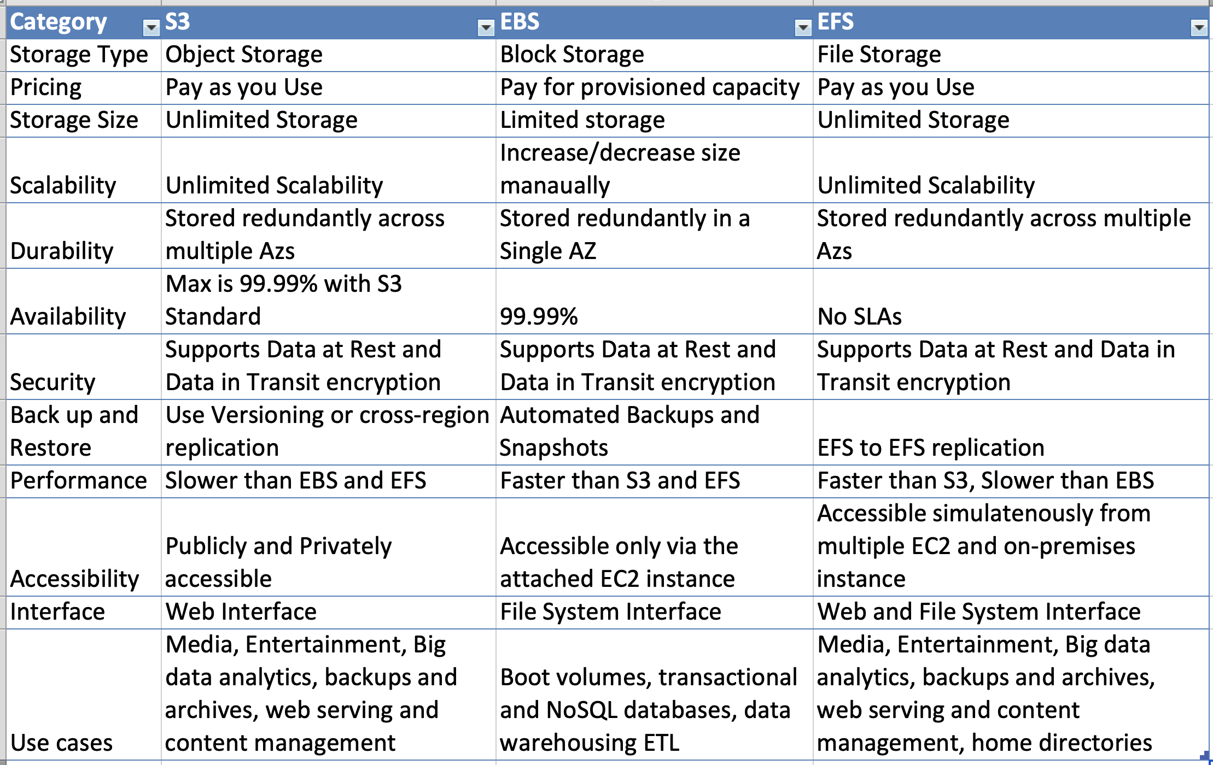

VPC is not resolving the server through DNS. What might be the issue, and how can you fix it?
To fix this problem, you need to enable the DNS hostname resolution, so that the problem resolves itself.

What is the VPC peering connection?
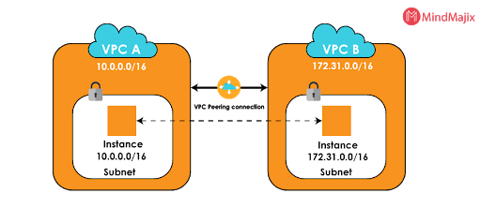
Ans: VPC peering connection is a networking connection that allows connecting one VPC with the other. It enables the route traffic between two VPCs using IPv6 and Ipv4 addresses. Instances within the VPCs behave like as they are in the same network.

How do you connect multiple sites to a VPC?
If you have multiple VPN connections, you can provide secure communication between sites using the AWS VPN CloudHub. Here’s a diagram that will show you how to connect various sites to a VPC:
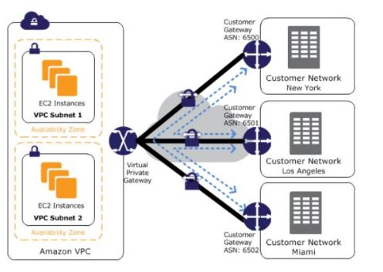

How do you monitor Amazon VPC?
You can monitor VPC by using:
- CloudWatch and CloudWatch logs
- VPC Flow Logs

How can you add an existing instance to a new Auto Scaling group?
Here’s how you can add an existing instance to a new Auto Scaling group:
- Open EC2 console
- Select your instance under Instances
- Choose Actions -> Instance Settings -> Attach to Auto Scaling Group
- Select a new Auto Scaling group
- Attach this group to the Instance
- Edit the Instance if needed
- Once done, you can successfully add the instance to a new Auto Scaling group

What is RTO and RPO in AWS?
RTO or Recovery Time Objective is the maximum time your business or organization is willing to wait for a recovery to complete in the wake of an outage.
On the other hand, RPO or Recovery Point Objective is the maximum amount of data loss your company is willing to accept as measured in time

How is AWS CloudFormation different from AWS Elastic Beanstalk?
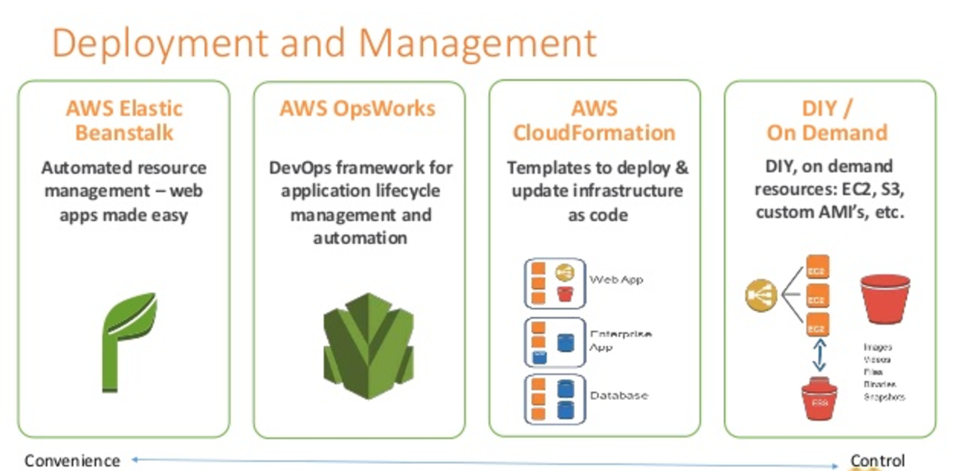
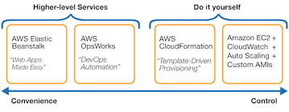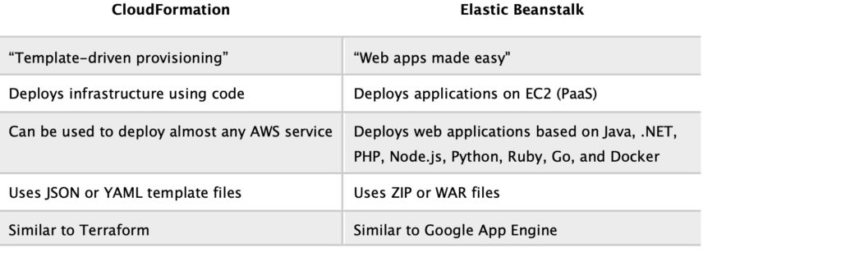

What happens when one of the resources in a stack cannot be created successfully?
If the resource in the stack cannot be created, then the CloudFormation automatically rolls back and terminates all the resources that were created in the CloudFormation template. This is a handy feature when you accidentally exceed your limit of Elastic IP addresses or don’t have access to an EC2 AMI.
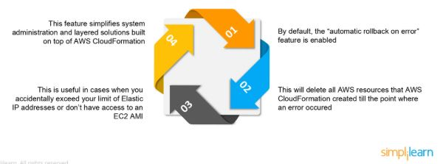

What is Elastic Beanstalk?
Ans: Elastic Beanstalk is the best service offered by AWS for deploying and managing applications. It assists applications developed in Java, .Net, Node.js, PHP, Ruby, and Python. When you deploy the application, Elastic beanstalk builts the selected supported platform versions and AWS services like S3, SNS, EC2, cloud watch and autoscaling to run your application.
Mention a few benefits of the Elastic beanstalk.
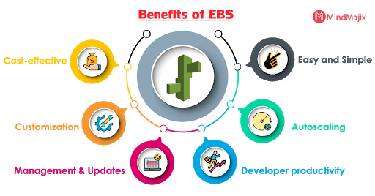

What is the difference between EBS and Instance Store?
EBS is a kind of permanent storage in which the data can be restored at a later point. When you save data in the EBS, it stays even after the lifetime of the EC2 instance. On the other hand, Instance Store is temporary storage that is physically attached to a host machine. With an Instance Store, you cannot detach one instance and attach it to another. Unlike in EBS, data in an Instance Store is lost if any instance is stopped or terminated.

What are the different uses of the various load balancers in AWS Elastic Load Balancing?
Application Load Balancer
- Used if you need flexible application management and TLS termination.
Network Load Balancer
- Used if you require extreme performance and static IPs for your applications.
Classic Load Balancer
- Used if your application is built within the EC2 Classic network

How many IP addresses are allowed for each account in AWS?
Ans: For each AWS account, 5 VPC elastic addresses are allowed.

There are four main AWS services related to CI/CD: CodeCommit, CodePipeline, CodeBuild, and CodeDeploy. Describe each of them.
AWS CodeCommit is essentially a managed service—i.e. Amazon manages and scales it behind the scenes for you, just like S3—for Git-based source control.
AWS CodeBuild is used to build, test, and generate artifacts—files that are generated from successful build steps—for deployment. This, too, is a managed service, doing provisioning and scaling automatically.
AWS CodeDeploy automates application deployments to several types of compute resources such as EC2 instances or ECS clusters.
AWS CodePipeline is a continuous delivery service that allows automating and integrating build, test, and deploy processes.

what EC2 instance metadata is. How does an EC2 instance get its IAM access key and secret key?
EC2 instance metadata is a service accessible from within EC2 instances, which allows querying or managing data about a given running instance.
It is possible to retrieve an instance’s IAM access key by accessing the iam/security-credentials/role-name metadata category. This returns a temporary set of credentials that the EC2 instance automatically uses for communicating with AWS services.

What is an SQS dead-letter queue (DLQ), and what could you use it for?
SQS is Amazon’s fully managed distributed queue service. Queues are useful for handling communication between different services or other components in distributed systems.
A DLQ is a special queue for messages that could not be processed properly. These queues are specially used for debugging and troubleshooting applications.

What are some differences between EKS, ECS, and Fargate?
EKS, or Amazon Elastic Container Service for Kubernetes, is Amazon’s managed Kubernetes service. This service provides a managed Kubernetes control plane that’s highly available, i.e. they run multiple master nodes for you.
ECS, or Elastic Container Service, is Amazon’s container orchestration service. This service is used to manage containers and their lifecycle within clusters.
Fargate is an ECS launch type which allows you to run containers in serverless clusters. In other words, it allows you to run containers without needing to manage the underlying cluster infrastructure.

Explain these Elastic Beanstalk deployment modes:
All at once: This is the fastest mode. In this case, Elastic Beanstalk will simply stop all the running instances and then will deploy the new version to these instances.
Immutable: In this mode, Elastic Beanstalk will create a new Auto Scaling Group and deploy the new instances there. Then, if the deployment succeeds, it will replace the old Auto Scaling Group with the newly created one.
Rolling: During the deployment, Elastic Beanstalk will deploy the new application version to some of the currently running instances, and repeat that process until all instances are running the same version. Using this mode, the application will run below capacity, but with zero downtime and no additional costs.
Rolling with additional batches: In this mode, Elastic Beanstalk will make sure there is no capacity reduction. It does so by first starting new instances with the new version of the application, and only then deploying the new version to the old instances.

1.How can you failover gracefully in AWS?
In case there is failure at one node, we can quickly remap and failover to another set of servers. It will lead to routing of traffic to the new servers.
It is also useful when we upgrade from old version to new version, or when some piece of hardware fails.
The Amazon Route 53 DNS failover feature also gives you the ability to monitor your website and automatically route your visitors to a backup site if your primary site becomes unavailable. You can host your backup site as a static website on Amazon S3 or as a separate dynamic environment.

Why AWS systems are built on “Design to Fail” approach?
At the core of an AWS system is, “Design for Fail” principle. It means if we design the software for failure nothing will fail.
If we follow a pessimist approach while designing architecture in the cloud, we will assume that things will fail. To handle such failure, we will always create a system that can have automated recovery from failure.
An AWS system is designed to automatically recover from design, execution and deploy stage failures.

When should we use a Classic Load Balancer vs. an Application load balancer?
A Classic Load Balancer is used for simple load balancing of traffic across multiple EC2 instances.
An Application Load Balancer is more suited for Microservices based architecture or container-based architecture. Mainly in these architecture there is a need to do load balancing as well as there is need to route traffic to multiple services on same EC2 instance

How will you scale an Amazon EC2 instance vertically?
We can use following steps to scale an Amazon EC2 instance:
- Step 1: Start an EC2 instance that is larger in capacity than the one we are currently using.
- Step 2: Pause the new instance and detach the root web volume from the server.
- Step 3: Stop the current live instance and detach its root volume
- Step 4: Note the unique device ID and attach that root volume to new server
- Step 5: Start the new EC2 instance again

What are the main features of Amazon CloudSearch?
- Amazon CloudSearch is mainly used for implementing a search solution of a website or application in AWS. It is highly scalable service and very easy to manage.
- It can index and search structured data as well as plain text.
- Main feature of Amazon CloudSearch are:
- Prefix search
- Full text search
- Boolean search
- Term boosting
- Range search
- Autocomplete Suggestions
- Faceting
- Highlighting

What is the command to copy all files from a S3 bucket to another bucket?
- We can use s2cmd for this purpose. The command would be as follows:
- s3cmd sync s3://source/foo/bucket/ s3://destination/foo/bucket/

What are the steps to change the root EBS device of an Amazon EC2 instance?
We can follow these steps to change the root EBS device of an EC2 instance:
- Stop Amazon EC2 instance
- Detach root EBS volume
- Attach another EBS volume
- Start Amazon EC2 instance

How can we find our regions and Availability Zones by using the Amazon EC2?
We can use Amazon EC2 Command Line Interface (CLI) to find the region and availability zone.
Run following command:
USER/> ec2-describe-regions
REGION us-west-1 ec2.us-west-1.amazonaws.com
REGION ap-northwest-1 ec2.ap-northwest-1.amazonaws.com
REGION ap-southwest-1 ec2.ap-southwest-1.amazonaws.com

Why encryption should be used in Amazon S3?
- Amazon S3 is simple storage service. We can create a highly-scalable, reliable, and low-latency data store in Amazon S3.
- We can use a simple web service interface to store and retrieve data in S3 buckets. These APIs are available at all the time from anywhere in the world. Since these APIs are widely accessible data stored needs security.
- To keep the data secure, we can encrypt it. Since S3 is Amazon proprietary technology, it is recommended to use our own Encryption strategy on the data stored in Amazon S3.

Ref.
https://www.knowledgepowerhouse.com/why-aws-systems-are-built-on-design-to-fail-approach/276

Chef – Interview

What is Chef?
It is a powerful automation platform that provides a way to transforms infrastructure into code. Chef is a tool for which you write scripts that are used to automate processes.
Chef Architecture Components
Chef Server | - The Chef Server is the central store of your infrastructure’s configuration data.  - The Chef Server stores the data necessary to configure your nodes & provides search.  - It is a powerful tool that allows you to dynamically drive node configuration based on data.
Chef Node | - A Node is any host that is configured using Chef-client.  - Chef-client runs on nodes & contacts the Chef Server for the information necessary to configure node.  - Nodes are sometimes referred as “clients” as they are machines that run the Chef-client software.
Chef Workstation | - A Chef Workstation is the host you use to modify your cookbooks and other configuration data.  - All the configurations are first tested in the Chef Workstation.  - Further, it is forwarded to the Chef Server.
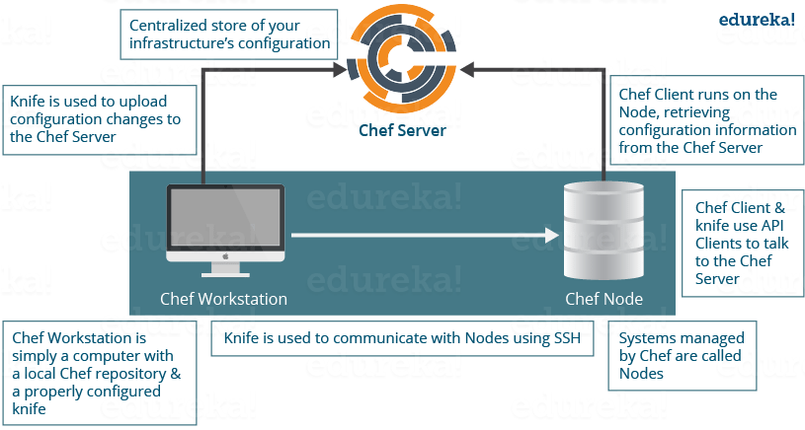

What is a Resource in Chef?
A Resource represents a piece of infrastructure and its desired state, such as
- a package that should be installed,
- a service that should be running, or
- a file that should be generated.
A block of Resource can be considered as a Recipe.
Specifies a resource type such as package, template, or service.

What is a Recipe in Chef?
A Recipe is a collection of Resources that describes a particular configuration or policy. A Recipe describes everything that is required to configure part of a system.

How does a Cookbook differ from a Recipe in Chef?
A Recipe is a collection of Resources, and primarily configures a software package or some piece of infrastructure.
A Cookbook groups together Recipes and other information in a way that is more manageable than having just Recipes alone.

What happens when you don’t specify a Resource’s action in Chef?
When you don’t specify a resource’s action, Chef applies the default action.
create is the file Resource’s default action
file 'C:UsersAdministratorchef-reposettings.ini' do
content 'greeting=hello world'
end
is same as the below resource:
file 'C:UsersAdministratorchef-reposettings.ini' do
action :create
content 'greeting=hello world'
end
because: create is the file Resource’s default action.

Are these two Chef recipes the same?
package 'httpd'
service 'httpd' do
action [:enable, :start]
end
&&

service 'httpd' do
action [:enable, :start]
end
package 'httpd'
No, they are not. Remember that Chef applies resources in the order they appear. So
- the first Recipe ensures that the httpd package is installed and then configures the service.
- The second Recipe configures the service and then ensures the package is installed.

Write a service Resource that stops and then disables the httpd service from starting when the system boots in Chef.
Use the below Resource to stop and disable the httpd service from starting when system boots.
service 'httpd' do
action [:stop, :disable]
end

How does Chef-apply differ from Chef-client?
Chef-apply is an executable program that runs a single Recipe from the command line. It is a part of the Chef development kit and a great way to explore resources.
Syntax for Chef-apply is:
chef-apply name_of_recipe.rb

Chef-client applies a Cookbook. It is used for production purposes where you typically run Chef-client to apply one or more cookbooks

What is run-list in Chef?
run-list lets you specify which Recipes to run, and the order in which to run them. The run-list is important when you have multiple Cookbooks, and the order in which they run matters.
Depending on the discussion if you think more explanation is required just mention the below points
A run-list is:
- An ordered list of roles and/or recipes that are run in the exact order defined in the run-list; if a recipe appears more than once in the run-list, the chef-client will not run it twice.
- Always specific to the node on which it runs; nodes may have a run-list that is identical to the run-list used by other nodes.
- Stored as part of the node object on the Chef server.
- Maintained using knife, and then uploaded from the workstation to the Chef server, or is maintained using the Chef management console.

What information do you need in order to bootstrap in Chef?
Just mention the information you need in order to bootstrap:
- Your node’s host name or public IP address.
- A user name and password you can log on to your node with.
- Alternatively, you can use key-based authentication instead of providing a user name and password.

How do you apply an updated Cookbook to your node in Chef?
There are three ways to apply an updated Cookbook to a node you can mention all or any one, I will suggest you to mention all three:
- Run knife ssh from your workstation.
- SSH directly into your server and run chef-client.
- You can also run chef-client as a daemon, or service, to check in with the Chef server on a regular interval, say every 15 or 30 minutes.

What is the role of Starter Kit in Chef?
Starter Kit will create the necessary configuration files like chef directory, knife.rb, the ORGANIZATION-validator.pem, and USER.pem files etc. with the correct information that is required to interact with the Chef server.
Now tell how to use Starter Kit, you can simply download the starter kit and then move it to the desired location on your workstation

What is the command you use to upload a cookbook to the Chef server?
You can directly mention the command to upload a cookbook to the Chef server “knife cookbook upload”.

Ref.
https://www.edureka.co/blog/interview-questions/chef-interview-questions/
https://intellipaat.com/blog/interview-question/chef-interview-questions-answers/
https://codingcompiler.com/chef-interview-questions-answers/
https://www.janbasktraining.com/blog/chef-interview-questions/

Ref.

